**✅ Day 4 Tasks**

**🐍 Python Tasks (Conditions + Lists)**

1. Write a program to check if a number is **positive, negative, or zero**.

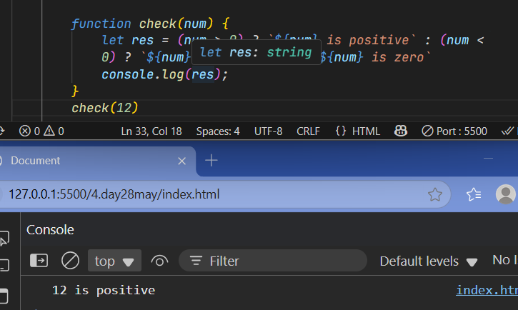

1. Create a list of 10 numbers. Write a function to **find the maximum and minimum** number from the list.

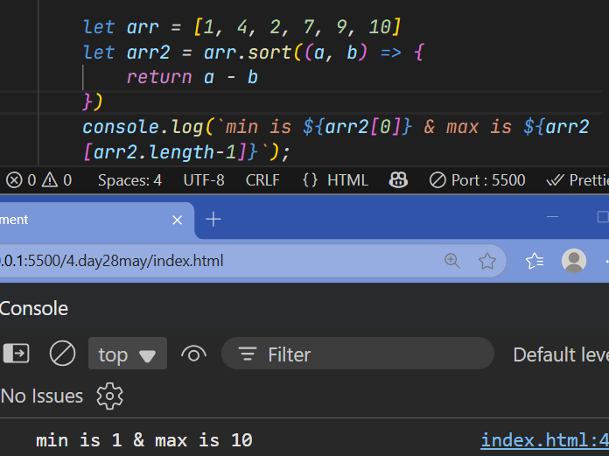

1. Write a program to **count even and odd numbers** in a list.

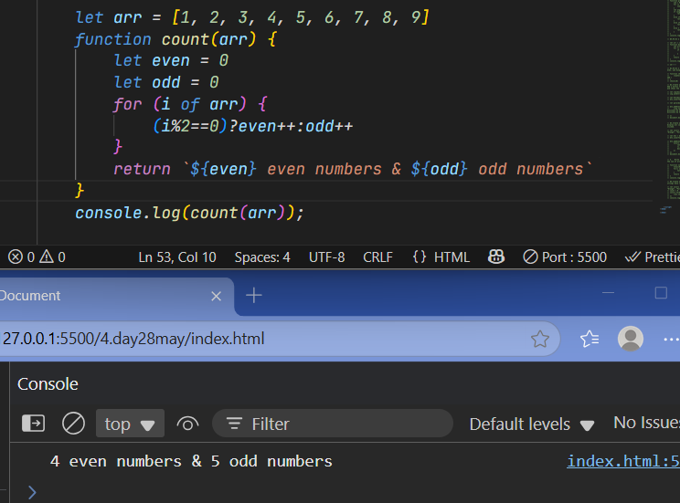

1. Create a list of student marks. Write a function to **return grades (A/B/C/Fail)** based on average marks.

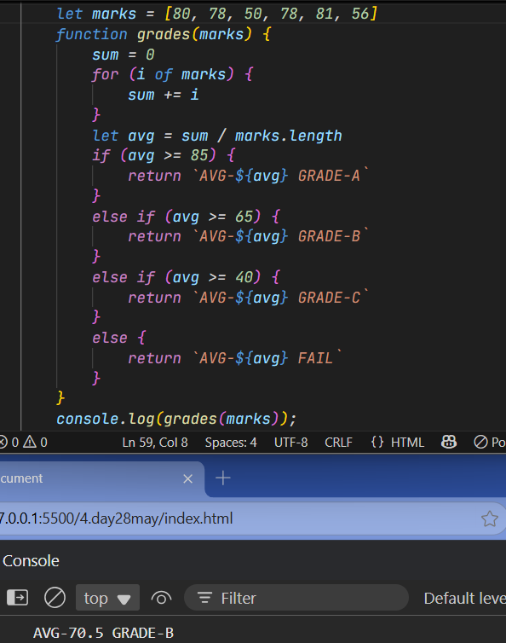

1. Write a function to **remove duplicates** from a list.

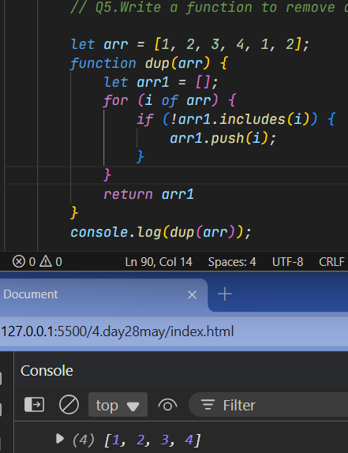

**🌐 JavaScript Tasks (Conditions + Arrays + DOM)**

1. Write a function that checks if a number is **odd or even**, and displays the result using alert().

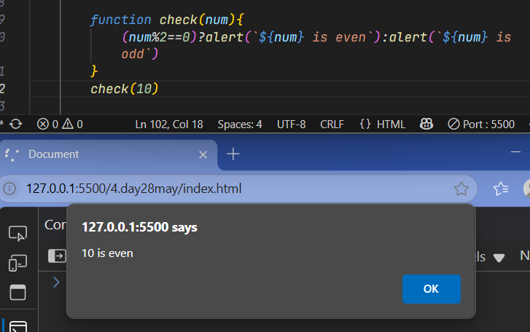

1. Create a form input where the user enters a number. Add a button that checks if the number is **divisible by 5** and shows the result in a <p> tag.

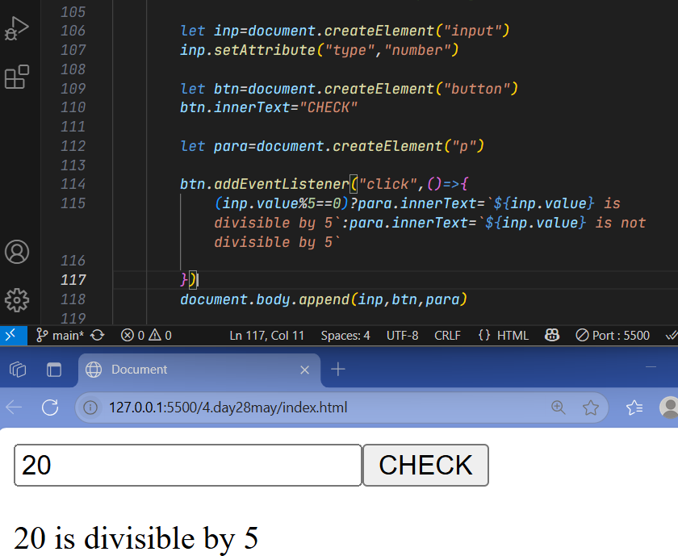

1. Create an array of colors. Write a function to **display all colors in a list (<ul>)** when a button is clicked.

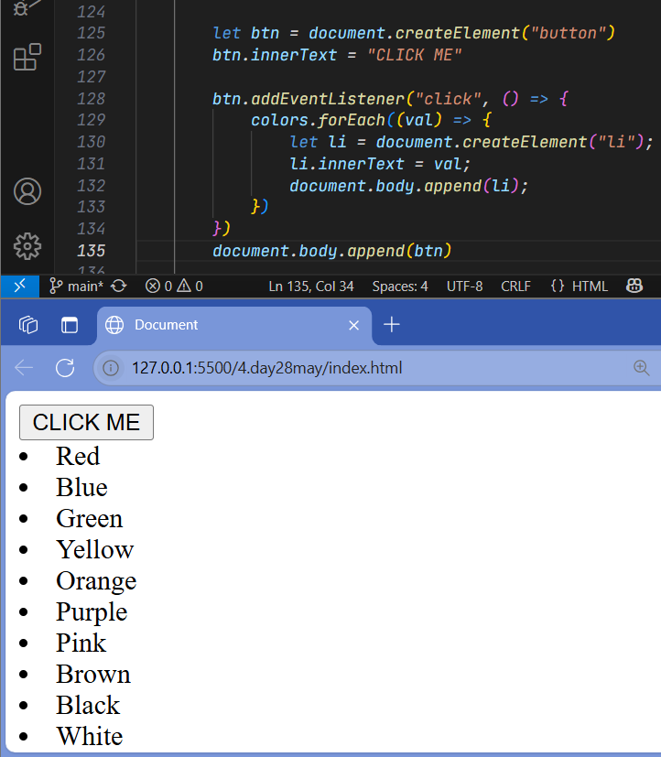

1. Write a function that accepts an array and returns the **sum of all elements**.

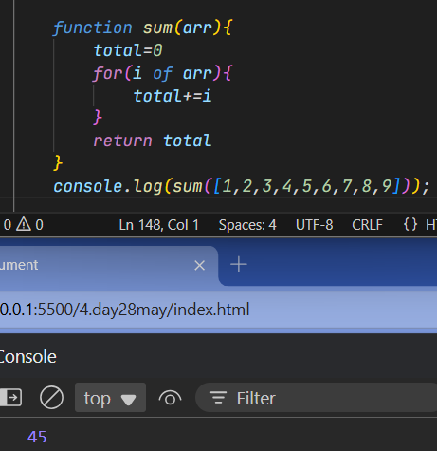

1. Create an array of strings and count how many strings have **length > 5**.

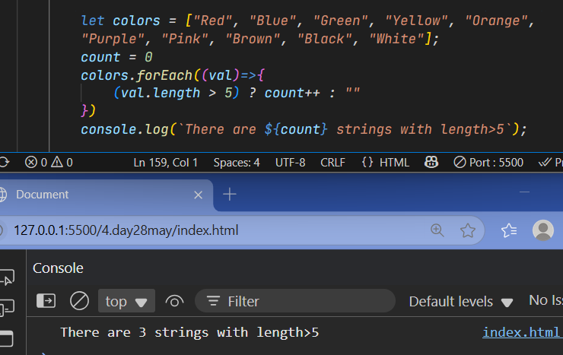

**🛢️ SQL Tasks (Conditions + Basic CRUD Practice)**

1. Create a table named students with columns: id, name, marks.
2. Insert 5 records into the students table.
3. Write a query to **select all students who scored more than 70**.
4. Update marks of a student whose name is "John" to 90.
5. Delete students whose marks are **less than 40**

